For oﬃce use only
Cremation number:
City of Belfast Crematorium
Applicant’s instructions to Crematorium
Part 1: Full name of deceased
Part 2: Applicant details
Name:
Address:
Postcode:
Telephone No:
Email:
Date:
Belfast City Council (BCC) is the Data Controller under the General Data Protection Regulation (GDPR) for
the personal data it gathers relating to the disposal of cremated remains. Belfast City Council is also seeking
your permission for the display of the deceased name on ﬂoral cards and electronic display screens. By
completing and signing this form you are providing your personal data and on a consensual basis and
permitting the display of the deceased name as above. Article 6 -1 (e) of GDPR additionally provides a
lawfulness for Belfast City Council to process this personal data as it is necessary for the performance of a
public task vested in Belfast City Council.
Your personal data is shared internally with staﬀ who are involved in providing this service and when
necessary, between internal departments with the purpose of supporting an eﬀective delivery of service.
Your personal data will not be shared or disclosed to any other organisation without your consent or unless
the law permits or places an obligation on the Belfast City Council to do so.
Your personal data is held and stored by Belfast City Council in a safe and secure manner and in compliance
with Data Protection legislation and in line with the Belfast City Council’s records retention and disposal
schedule.
If you have any queries regarding the processing of your personal data or you wish access to it, please
contact the Belfast City Council’s Bereavement Services Oﬃce, Cecil Ward Building Belfast BT2 8BP Tel: 028
9027 0296 or email cemeteries@belfastcity.gov.uk
Once you have completed this form, please upload it together
with forms A, B (including pacemaker/ﬁxion form), C, and
GRO21 form (or where the death has been reported to the
Coroner, a Coroner’s Order for Cremation) to Plotbox for the Medical
Referee to review at the Bereavement Services Oﬃce. All forms must be
submitted no later than TWO working days before the cremation
date and before the following times: - Monday to Thursday
12noon, Friday and Saturday 11am.
www.belfastcity.gov.uk

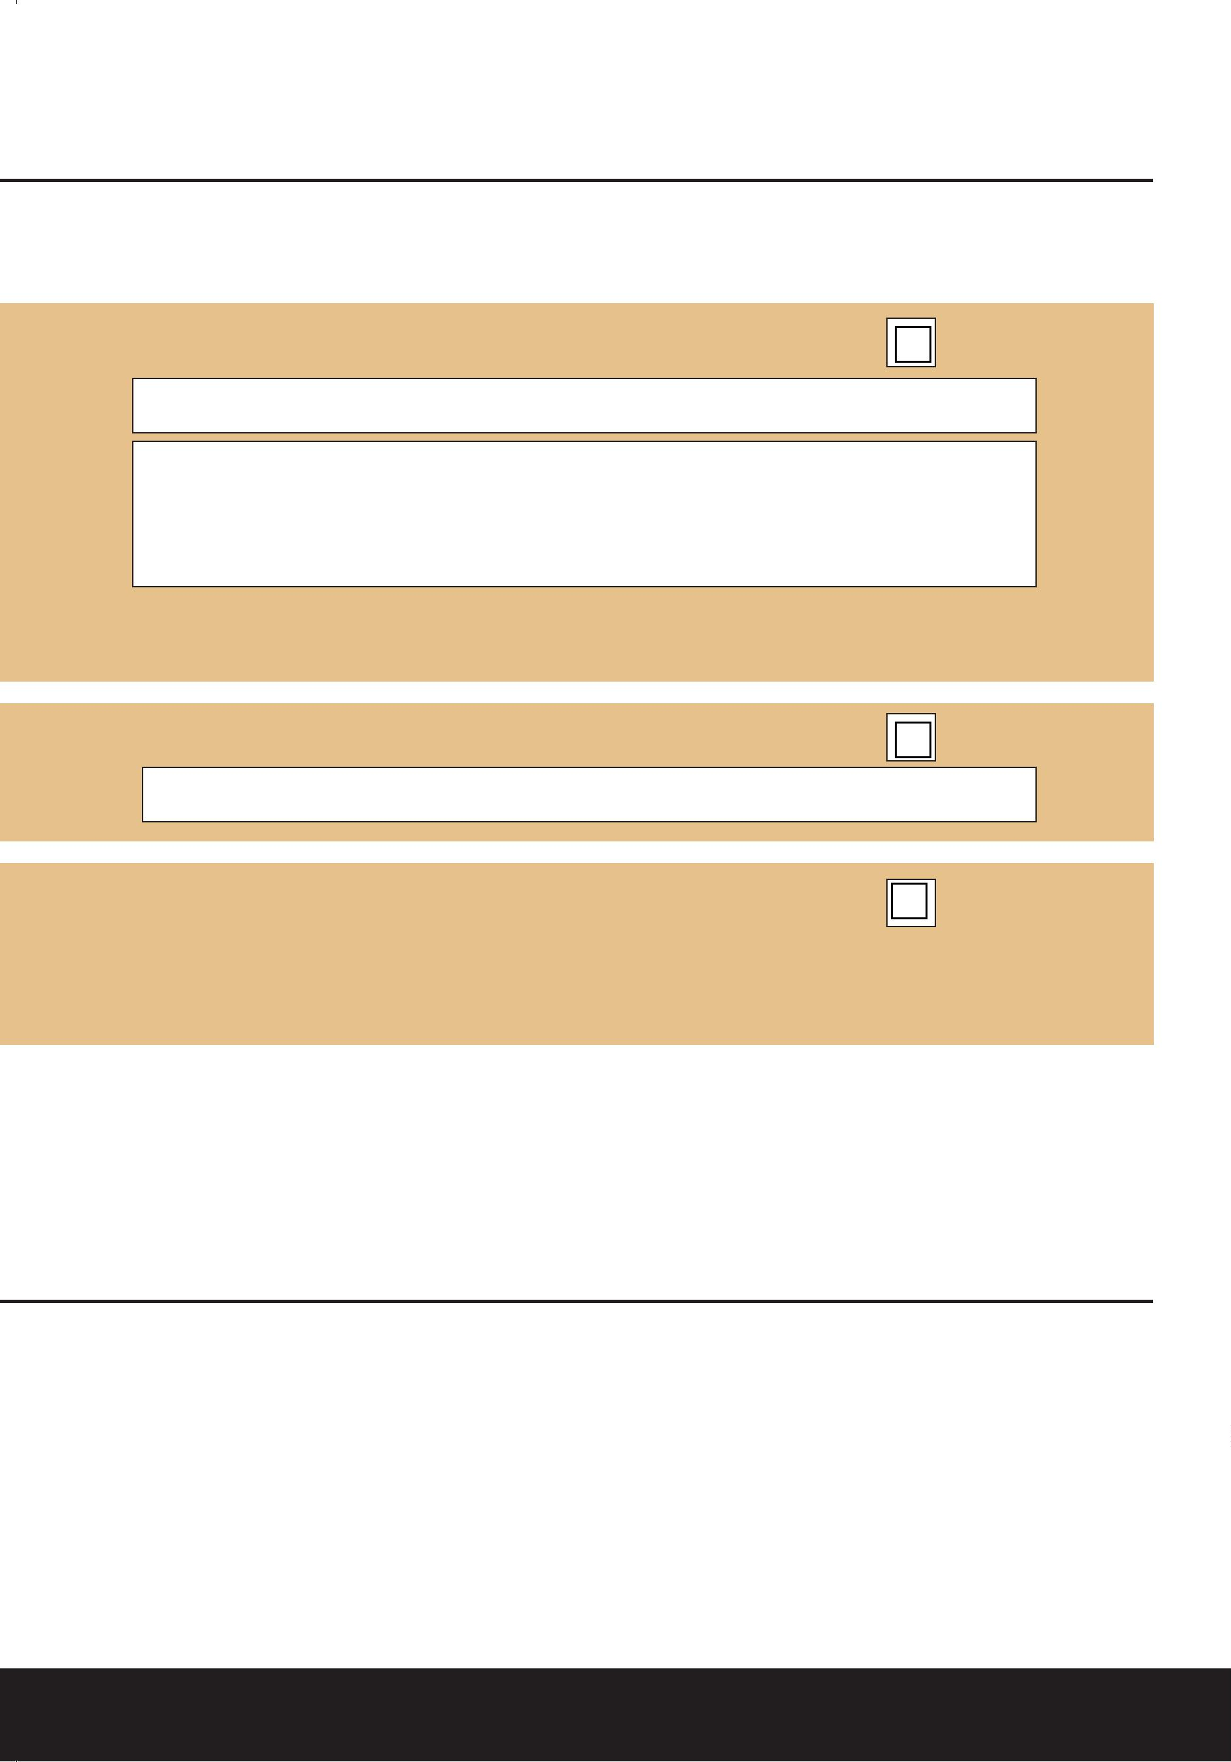Part 3: Cremated Remains
This section is used to record what will happen to the cremated remains after the cremation. The term cremated remains means the material (other than any metal) to which human remains are reduced by cremation, including the coﬃn and any clothing.
 | A. |  | Collection by the applicant or their representative
Name of applicant or representative: Collection from 2pm the next working day.
Where applicable; address of representative:
We will give you the cremated remains in a standard biodegradable urn. You can collect these from 2pm the
next working day following the cremation service. You must show photographic identiﬁcation when collecting
cremated remains.
 | B. |  | Collection by Funeral Director, who arranged the cremation.
Name of Funeral Director: Collection from 2pm the next working day.
C. Scatter the cremated remains in the Garden of Remembrance
at the Crematorium without any relatives present.
Cremated remains are normally scattered on the lawns in the Garden of Remembrance no sooner than ﬁve days
after the cremation service. We keep a record of the lawn where the remains are scattered, but it is not possible
to give their exact location.
After the cremation, we will hold cremated remains in the City of Belfast Crematorium for a
maximum of 16 weeks from the date of cremation. If you do not collect the cremated remains in
this time frame, we will scatter the remains in the Garden of Remembrance. We will contact you
two weeks before we intend to scatter the remains.
Part 4: Floral tributes
Unfortunately, the Crematorium cannot take any responsibility for floral tributes. All ﬂoral tributes to be removed from the Crematorium building after each service.
ww.belfastcity.gov.uk

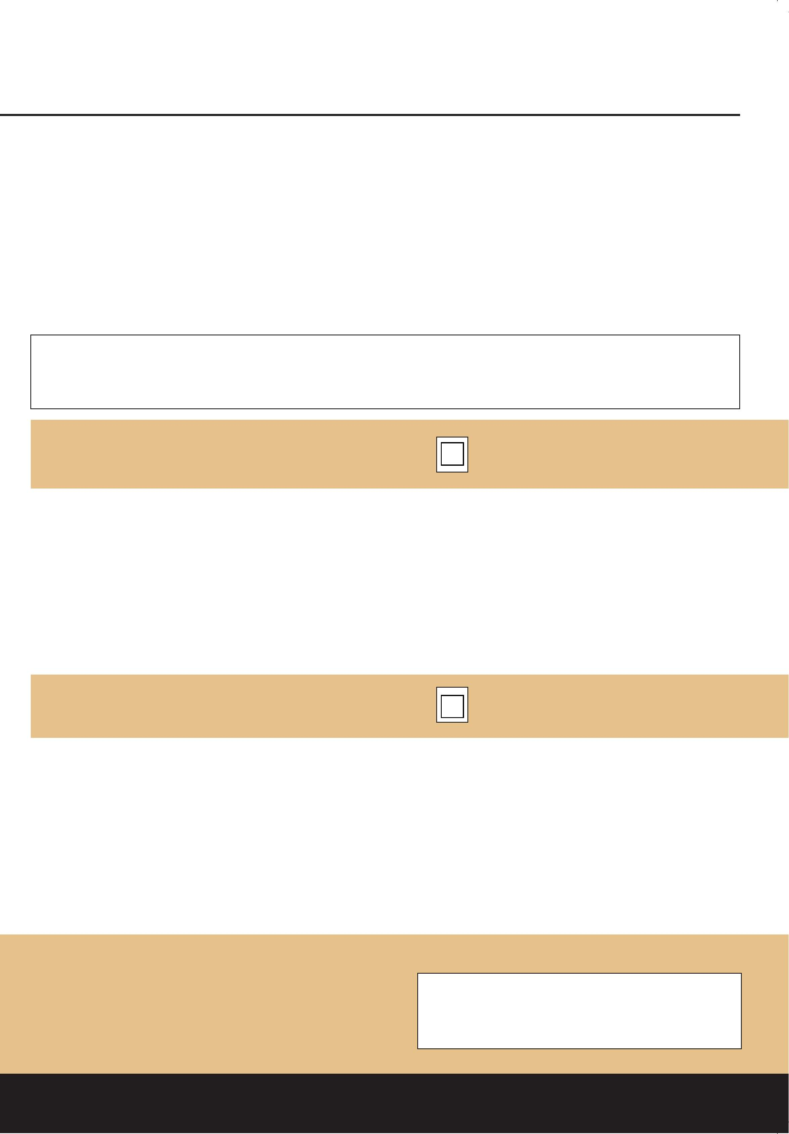Part 5: Environmental Policy
A: Consent for disposal of metals remaining after cremation
Please tell us how you want to dispose of metals recovered following cremation
Ferrous metals used in the construction of the coﬃn, metal used in medical implants and non-
ferrous metals which may include an unrecognisable element of precious material will be recycled
for charitable purposes through the Institute of ‘Cemetery and Crematorium Management Recycling
of Metal Following Cremation Scheme’.
If you want to dispose of the metals in any other way, please tick the box below and metals will be
returned to you with the cremated remains.
Soft metals (such as gold and silver) melt into tiny globules and combine with the cremated
remains. These cannot be returned separately. We recommend that precious metals in the form of
jewellery are not cremated with the deceased.
Only tick if you need all metal residues recovered
following cremation to be returned to you.
B: Holding over
In accordance with the Code of Cremation Practice, City of Belfast Crematoriums policy allows
for the holding over of the coﬃn. We will carry out all cremations as soon as possible after the
funeral service and will only hold over in the event of health and safety, environmental and
operational reasons or mechanical failure. In circumstances were we are required to hold over
without consent, we will inform the applicant via the Funeral Director.
Only tick if you do not consent to holding over
Applicant’s signature:
www.belfastcity.gov.uk

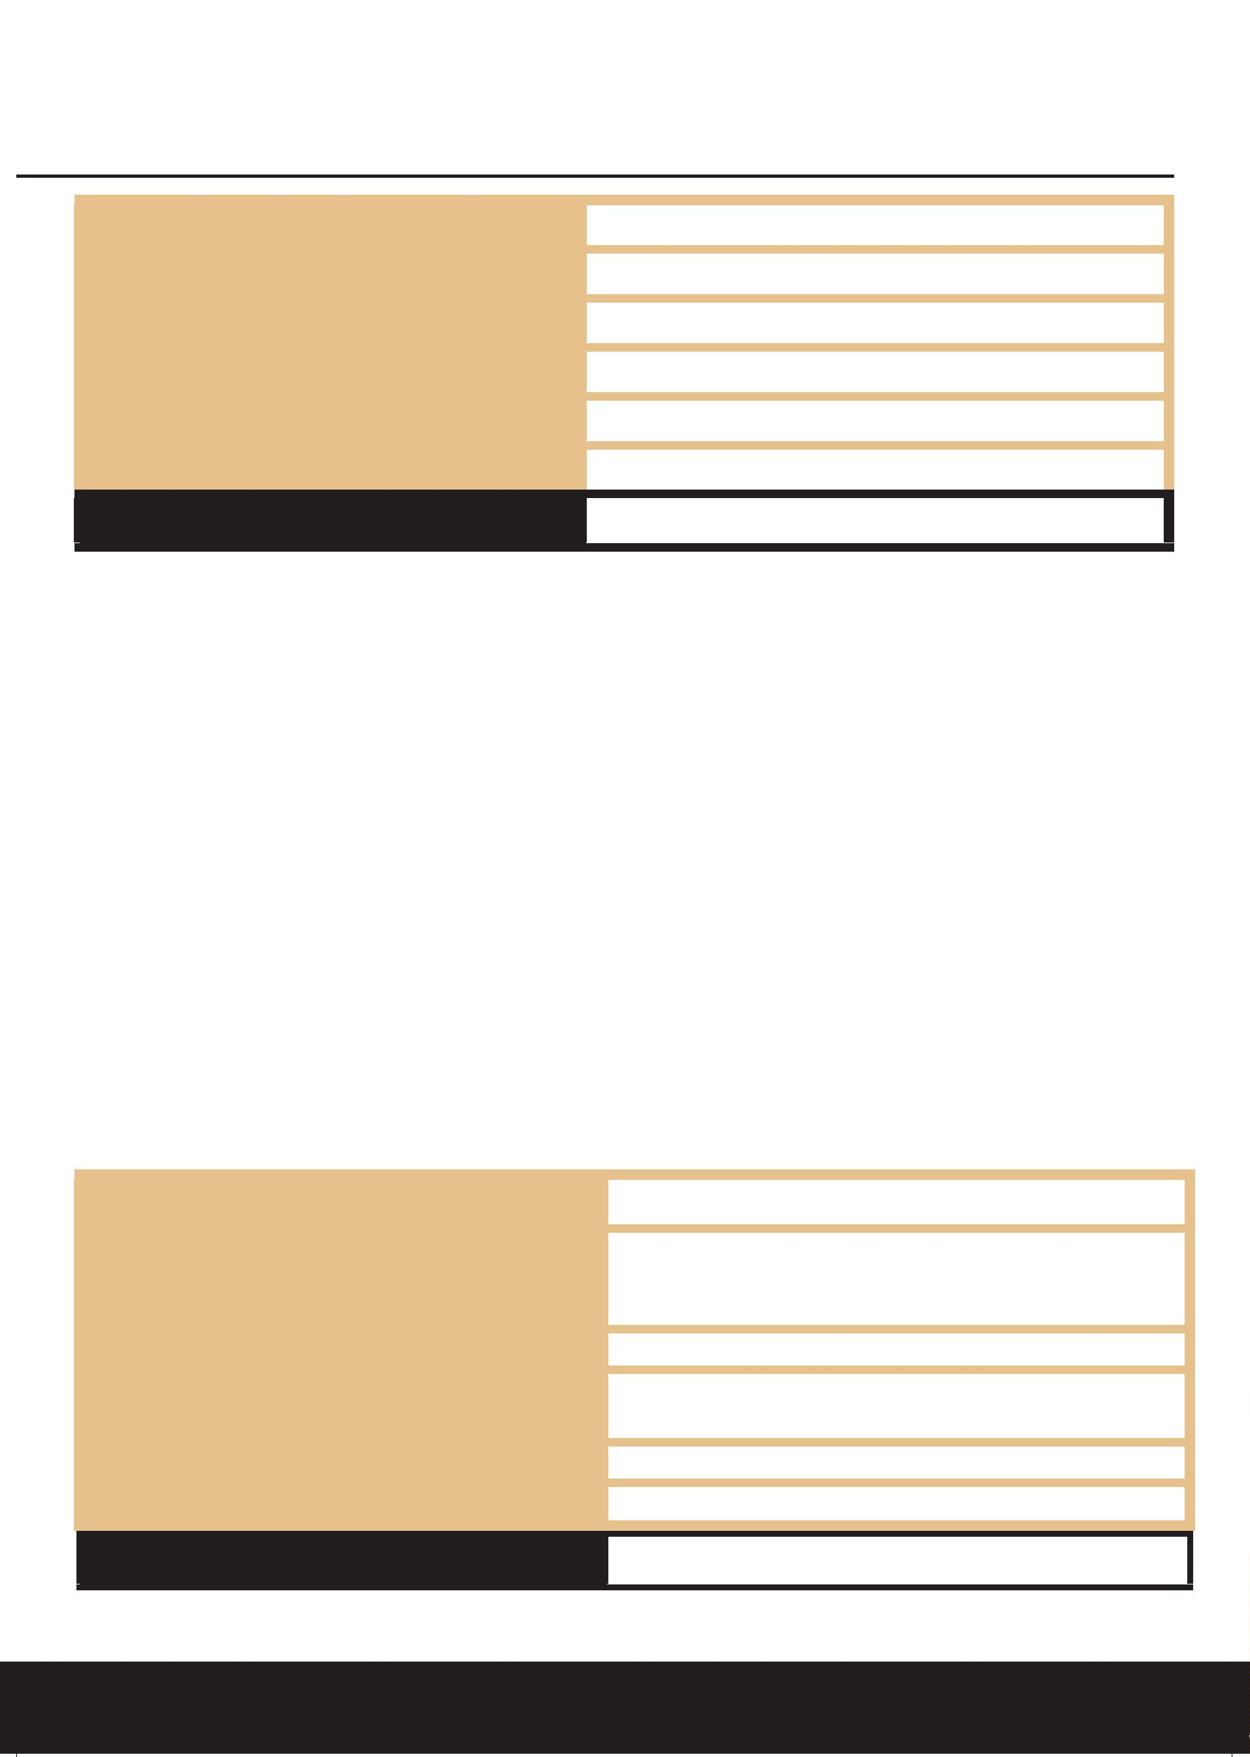
Part 6: Coﬃn Information
Coﬃn Accreditation Number
Combined Weight of Coﬃn and Deceased
Length of Coﬃn
Width at Shoulder
Depth of Coﬃn
Additional Control Measures
For oﬃce use only

CREMATION: REQUIREMENTS FOR THE COFFIN AND CONTENTS
Identiﬁcation
The Funeral Director must ensure that coﬃn has a nameplate bearing the full name of the deceased, which shall be checked by the Crematorium Oﬃcial before entry into the Chapel. Any variation from the Application for Cremation details will require a written declaration before the cremation can proceed.
Measurements
The external measurements of a coﬃn (including the handles or any other adornments) shall not exceed 83 inches in length, 32 inches in width or29.5 inches in depth. Any coﬃns that exceed any of these individual measurements will not be accepted for cremation.
Coﬃn Accreditation
The coﬃn must be certiﬁed suitable for cremation in accordance with The Funeral Furnishing Manufacturers Association (FFMA) or The Coﬃn, Casket and Shroud Association (CCSA).
Contents of coﬃn
In order to minimise the release of pollutants to air, it is recommended that clothing should be of natural ﬁbres such as cotton, linen and wool, whereas shoes or any material manufactured from PVC should not be included. Additional items, particularly of glass or plastic must not be placed in the coﬃn due to particulate emissions during combustion within the cremation process. No other cremated remains (human or pet) should be placed within the coﬃn. The submission of
Guidance for funeral directors when completing the ‘combined weight’ section.
It is recommended that funeral directors should to obtain access to suitable weighing equipment as soon as possible. However, in the event that suitable weighing equipment is not available, an estimated weight should be provided. This can be obtained provided that, the deceased person is in your care prior to the cremation form being sent to the cremation authority; you are able to provide a useful estimate based on the information available to you; and you are able to get the information from the client (considering the likelihood of causing upset to your client). When providing an estimated weight, it is important that the fact that it is an estimation rather than an accurate reflection of the combined weight is made clear. It is recommended that the funeral director writes the words “estimated weight” next to the estimated figure.
Funeral Director (to be completed by funeral director if services are used)
Name
Address
Telephone
I have read and agree to abide by the
requirements for the coﬃn and contents Date (DD/MM/YYYY): Additional Control Measures
For oﬃce use only
On arrival at The City of Belfast Crematorium, crematorium staﬀ may decline the acceptance
of the coﬃn, if it does not comply with these requirements.
www.belfastcity.gov.uk

